Moving Mobile Device to Edge Server Resource Allocation
A report submitted in partial fulfillment of the requirements for
the award of the degree of
Master of Science
Computer Science
By
Sagar Timalsena
(24419CMP025)

Under the Supervision of
Dr. Anshul Verma
Department of Computer Science
Institute of Science
Banaras Hindu University, Varanasi – 221005
2026

ABSTRACT
The rapid advancement of mobile computing and edge computing has increased the need for efficient resource allocation in dynamic network environments. Mobile devices frequently change their locations, resulting in continuous variations in connectivity and communication quality with nearby edge servers. These changes create challenges in maintaining stable communication links and ensuring effective utilization of edge resources. To address these issues, this research proposes a Moving Mobile Device to Edge Server Resource Allocation framework that dynamically assigns mobile devices to suitable edge servers based on connectivity conditions and resource availability. The framework utilizes a dynamic connectivity matrix to continuously monitor and update the communication relationships between mobile devices and edge servers. Mobile devices periodically transmit their location information, and after considering communication delays, updated connectivity data is used to generate the connectivity matrix. The allocation mechanism considers several important factors, including device mobility, communication range, connectivity status, server resource capacity, and current workload, to determine the most appropriate edge server for each device. A simulation environment was developed in Python to evaluate the proposed framework under realistic conditions involving mobile devices, heterogeneous edge servers, communication delays, and dynamic mobility scenarios. System performance was assessed using metrics such as winner miners, social welfare, resource utilization, connectivity ratio, and allocation success rate. Experimental results indicate that the proposed connectivity-aware allocation mechanism effectively adapts to changing network conditions, improves resource utilization, maintains reliable connectivity, and increases allocation success. The framework demonstrates its capability to support resource-intensive applications, particularly blockchain mining, in mobile edge computing environments. Overall, the proposed approach provides an efficient and scalable solution for intelligent resource management, ensuring better performance, improved connectivity, and optimal utilization of edge computing resources in dynamic mobile networks.
Keywords: Mobile Edge Computing, Edge Server Allocation, Mobile Device Mobility, Connectivity Matrix, Resource Allocation, Communication Delay, Blockchain Mining.

CANDIDATE’S DECLARATION
I hereby certify that the work, which is being presented in the project report, Moving Mobile Device to Edge Server Resource Allocation, in partial fulfilment of the requirement for the award of the Degree of Master of Computer Science and submitted to the institution is an authentic record of my own work carried out during the period January 2026 - May 2026 under the supervision of Dr. Anshul Verma.
I also cited the reference about the text(s)/figure(s)/table(s)/equation(s) from where they have been taken.
The matter presented in this report has not been submitted elsewhere for the award of any other degree or diploma from any institutions.

Date:01/06/2026 Signature of the Candidate

This is to certify that the above statement made by the candidate is correct to the best of my knowledge. The Viva-Voce examination of Sagar Timalsena, M.Sc. Student has been held on 01/06/2026

_______________________ _____________________
Signature of Signature of
Research Supervisor(s) Head of the Department

_____________________
Signature of External Evaluators

ACKNOWLEDGEMENTS
I would like to express my heartfelt gratitude to everyone who supported me throughout the completion of this project. I am deeply thankful to my project supervisor, Dr. Anshul Verma, for their constant guidance, encouragement, and insightful feedback. Their expertise has played a crucial role in shaping the direction and quality of this work.
I am equally grateful to the professors and mentors of the Department of Computer Science, Banaras Hindu University, whose teachings and support have provided me with a strong academic foundation and the skills necessary for this project.
My sincere thanks also go to my family and friends for their unwavering encouragement, patience, and motivation throughout this journey. Their support has been a continuous source of strength.
Lastly, I extend my appreciation to all the participants and contributors whose involvement and cooperation have been vital to the successful completion of this project.

TABLE OF CONTENTS
ABSTRACT i
CANDIDATE’S DECLARATION ii
ACKNOWLEDGEMENTS iii
TABLE OF CONTENTS iv
LIST OF FIGURES vi
LIST OF TABLE vii
LIST OF ABBREVIATIONS viii
CHAPTER 1: INTRODUCTION 1
1.1 Introduction 1
1.2 Problem Statement 3
1.3 Objectives 3
CHAPTER 2: LITERATURE REVIEW 4
CHAPTER 3: METHODOLOGY 8
3.1 Overview 8
3.2 System Model 10
3.3 Mobility Model 10
3.4 Communication Process 11
3.4.1 Stage 1: Position Request 11
3.4.2 Stage 2: Delayed Miner Data Transmission 11
3.5 Connectivity Matrix Design 11
3.6 Edge Server Allocation 12
3.7 Blockchain Mining Process 13
3.8 Simulation Parameters 14
3.9 Performance Metrics 15
3.9.1 Allocation Efficiency 15
3.9.2 Connectivity Ratio 15
3.9.3 Communication Delay 17
3.9.4 Mining Success Rate 17
3.9.5 Edge Server Utilization 17
3.9.6 Network Stability 18
3.9.7 Throughput 18
CHAPTER 4: EXPERIMENT SETTINGS 19
4.1 Experimental Environment 19
4.2 Simulation Area 19
4.3 Miner Configuration 19
4.4 Vehicle Mobility Settings 20
4.5 Edge Server Configuration 22
4.6 Communication Delay Settings 22
4.7 Simulation Time Settings 22
4.8 Distance-Evolution-Aware Connectivity 23
4.9 Adaptive Connectivity Range 24
4.10 Connectivity Matrix Generation 25
4.11 Multi-Server Connectivity Analysis 25
4.12 Miner Priority Calculation 26
4.13 Final Miner Selection Score 26
4.14 Performance Evaluation Metrics 27
4.15 Social Welfare 28
4.16 Resource Utilization 28
4.17 Connectivity Ratio 29
4.18 Experimental Comparison Factors 30
4.19 Resource Allocation Strategy 30
CHAPTER 5: RESULTS AND DISCUSSION 32
5.1 Overview 32
5.2 Winner Miner Analysis 32
5.3 Social Welfare Analysis 33
5.4 Resource Utilization Analysis 34
5.5 Connectivity Ratio 35
CHAPTER 6: CONCLUSION AND FUTURE WORK 37
6.1 Conclusion 37
6.2 Future Work 38
REFERENCE 40

LIST OF FIGURES
Figure 1 System Flowchart 8
Figure 2 Winner Miners vs Time 26
Figure 3 Social Welfare Analysis 27
Figure 4 Resource Utilization Analysis 28
Figure 5 Connectivity Ratio 29

LIST OF TABLE
Table 1 Miner Configuration Parameters 18
Table 2 Vehicle Mobility Settings 18
Table 3 Edge Server Parameters 19
Table 4 Distance-Evolution Interpretation 21
Table 5 Adaptive Connectivity Range 21
Table 6 Performance Evaluation Metrics 23
Table 7 Experimental Comparison Factors 25

LIST OF ABBREVIATIONS
AI | Artificial Intelligence
CDAM | Constant Demand Auction Mechanism
CPU | Central Processing Unit
ECSP | Edge Computing Service Provider
IoT | Internet of Things
IoV | Internet of Vehicles
MDAM | Multi-Demand Auction Mechanism
MEC | Mobile Edge Computing
ML | Machine Learning
PoW | Proof of Work
SW | Social Welfare
VCG | Vickrey–Clarke–Groves Mechanism
Δ (Delta) | Connectivity Matrix

CHAPTER 1: INTRODUCTION

Introduction
The rapid growth of blockchain technology, wireless communication, and mobile computing has increased the demand for efficient resource management in distributed networks. Blockchain is a decentralized technology that provides security, transparency, and trust without relying on a central authority. Blockchain networks are widely used in applications such as cryptocurrency, smart contracts, healthcare, supply chain management, and data sharing systems. One of the most important processes in blockchain systems is mining, where miners validate transactions and generate new blocks through computational operations. However, blockchain mining requires high computational power, energy consumption, and processing time, which makes it difficult for mobile devices with limited resources to perform mining tasks efficiently[1].
Mobile devices such as smartphones, IoT devices, and portable computing systems have limited battery power, storage capacity, and processing capability. Performing blockchain mining directly on these devices can quickly consume energy and reduce device performance[2]. In addition, blockchain applications often require low latency and fast transaction validation for real-time services. Traditional cloud computing solutions are not always suitable because mining data must travel to distant cloud servers, which introduces communication delay, network congestion, and higher bandwidth usage.
To overcome these limitations, MEC has emerged as an effective solution for supporting blockchain mining in mobile environments. In MEC systems, edge servers are deployed close to mobile devices to provide nearby computational resources. Instead of performing mining locally or sending tasks to distant cloud servers, mobile devices can offload blockchain mining tasks to nearby edge servers. This approach reduces processing delay, improves mining speed, decreases energy consumption, and enhances overall system performance[3].
However, efficient allocation of moving mobile devices to edge servers remains a major challenge in MEC-based blockchain mining systems. Mobile devices continuously move from one location to another, causing dynamic changes in communication links and connectivity conditions. A mobile device connected to one edge server may move out of its communication range after a short period of time. As a result, mining tasks may need to be transferred to another edge server. Frequent task migration and server handovers can increase communication delay, packet loss, and mining interruption, which negatively affect blockchain performance.
Most existing edge server allocation methods mainly focus on reducing latency, balancing workload, or minimizing energy consumption. However, many approaches do not consider the movement direction and dynamic connectivity of mobile devices during blockchain mining. In practical mobile environments, movement direction plays an important role in connection stability. A device moving toward an edge server may maintain a stable communication link for a longer time, while a device moving away may quickly disconnect. Ignoring movement behavior can lead to unstable mining performance and unnecessary reallocations.
Another important challenge is maintaining updated connectivity information between mobile devices and edge servers. Since the network topology changes continuously, real-time connectivity management becomes necessary for efficient mining task allocation. A dynamic connectivity matrix can be used to represent communication relationships between mobile devices and available edge servers. The connectivity matrix changes according to device movement, communication range, and network conditions[4].
To address these challenges, this paper proposes a Direction-Aware Moving Mobile Device to Edge Server Allocation method for blockchain mining using a dynamic connectivity matrix. In the proposed system, mobile devices periodically send their position information to the edge controller. Based on device location, movement direction, edge server workload, and communication conditions, the system dynamically selects the most suitable edge server for blockchain mining tasks.
The proposed method aims to reduce latency, minimize unnecessary handovers, improve connection stability, and increase mining efficiency. By considering movement direction and dynamic connectivity during edge server allocation, the proposed approach can provide more reliable and efficient blockchain mining performance in highly dynamic mobile environments.
The main contributions of this paper include the development of a dynamic connectivity matrix for real-time edge server selection, a direction-aware allocation mechanism for stable mining task execution, and an efficient resource management framework for blockchain mining in MEC environments. The proposed system is expected to improve mining performance, reduce energy consumption, and provide better workload balancing among edge servers compared with traditional allocation methods.

Problem Statement
Blockchain mining requires high computational power, low latency, and stable network connectivity. However, mobile devices have limited processing capability, battery power, and storage, making direct blockchain mining inefficient. MEC helps by allowing mobile devices to offload mining tasks to nearby edge servers. Nevertheless, continuous movement of mobile devices causes frequent changes in connectivity and communication conditions. This may lead to repeated edge server handovers, increased delay, packet loss, and unstable mining performance. Existing allocation methods often ignore movement direction and dynamic connectivity. Therefore, an efficient and mobility-aware edge server allocation method is needed to improve blockchain mining performance.

Objectives
The main objective of this research is to develop an efficient edge server allocation system for blockchain mining in MEC environments. The proposed system aims to improve mining performance for moving mobile devices by reducing delay, improving connectivity stability, and minimizing unnecessary handovers.
- To minimize unnecessary edge server handovers caused by mobile device movement.
- To improve connection stability between mobile devices and edge servers.
- To design a dynamic connectivity matrix for real-time device and server - communication management.

CHAPTER 2: LITERATURE REVIEW
The rapid development of MEC, blockchain technology, wireless communication, and distributed computing has attracted significant attention from researchers in recent years. Many studies have focused on improving computational efficiency, reducing latency, enhancing security, and optimizing resource allocation in mobile and edge computing environments. Blockchain and MEC integration has become an important research area because blockchain applications require high computational power, fast processing capability, and secure communication, while MEC provides low-latency computing resources close to mobile users. This chapter reviews previous studies related to blockchain mining, mobile edge computing, task offloading, mobility management, dynamic resource allocation, and edge server selection.
Blockchain technology is widely used in decentralized systems because of its ability to provide transparency, security, immutability, and trust without requiring a centralized authority. Blockchain networks validate and store transactions using consensus mechanisms such as Proof of Work (PoW), Proof of Stake (PoS), and other mining techniques. However, blockchain mining requires intensive computational resources, high energy consumption, and continuous network connectivity. Traditional blockchain mining systems are usually designed for powerful computing devices with high processing capability. Mobile devices, on the other hand, have limited battery power, storage, and computational resources, making direct blockchain mining difficult and inefficient[5].
To solve this problem, several researchers proposed integrating blockchain with Mobile Edge Computing. MEC places edge servers close to mobile users to provide nearby computational resources and low-latency services. Instead of processing mining tasks locally or sending them to distant cloud servers, mobile devices can offload blockchain mining tasks to nearby edge servers.[6] This reduces communication delay, bandwidth usage, and energy consumption while improving mining efficiency. Researchers have shown that edge-assisted blockchain systems can significantly improve transaction processing speed and overall system performance compared with traditional cloud-based approaches.
Many studies have focused on task offloading strategies in MEC environments. Task offloading refers to transferring computationally intensive tasks from resource-limited mobile devices to more powerful edge servers. Researchers have proposed different optimization methods for efficient task allocation and resource management. These methods mainly aim to minimize latency, reduce energy consumption, balance computational workload, and improve quality of service. Various approaches such as heuristic algorithms, game theory, deep learning, reinforcement learning, and optimization techniques have been applied for efficient edge resource allocation[7].
Several existing studies use latency-aware and energy-aware allocation methods to improve MEC performance. These methods select edge servers based on communication delay, server processing capability, and network conditions. Some researchers also introduced load-balancing techniques to distribute workloads among multiple edge servers and avoid server overload. Although these approaches improve resource utilization, many of them assume relatively stable network conditions and static user locations[8].
Mobility management is another important research topic in MEC systems. Since mobile devices continuously move from one location to another, communication links between devices and edge servers change dynamically over time. Device mobility may cause frequent communication interruptions, increased delay, packet loss, and repeated edge server handovers. To address these issues, researchers proposed mobility-aware task offloading and handover management methods.
Some studies used mobility prediction techniques to estimate future positions of mobile devices and improve server selection decisions. By predicting movement patterns, the system can allocate tasks to edge servers that are likely to maintain stable communication for longer durations. Other approaches considered user trajectory information, device speed, and movement history for dynamic resource allocation. These methods help reduce unnecessary handovers and improve communication stability in highly dynamic MEC environments.
Connectivity management has also received significant attention in recent research. Since communication conditions continuously change due to mobility, maintaining updated connectivity information between mobile devices and edge servers is essential. Several researchers used connectivity matrices and graph-based models to represent communication relationships in dynamic networks. A connectivity matrix indicates whether a mobile device can communicate with a particular edge server at a given time. Dynamic connectivity management helps systems quickly identify available edge servers and make better allocation decisions.
Despite the large number of studies on MEC and blockchain integration, several limitations still exist in current research. Most existing resource allocation methods mainly focus on minimizing latency or energy consumption while ignoring movement direction and connectivity stability of mobile devices. In practical mobile environments, movement direction plays an important role in communication reliability. A mobile device moving toward an edge server can maintain stable communication for a longer period, while a device moving away may quickly lose connectivity. Ignoring movement direction may result in unstable communication links and frequent task migration.
In addition, many existing studies do not specifically focus on blockchain mining for moving mobile devices. Blockchain mining introduces additional challenges because mining tasks require continuous computational resources, stable communication, and synchronization among miners. Frequent edge server handovers during mining operations may interrupt block generation, increase mining delay, and reduce system performance. Therefore, efficient mobility-aware edge server allocation is necessary for stable blockchain mining in MEC environments.
Another limitation of current studies is the lack of integration between dynamic connectivity matrices, movement direction analysis, and blockchain mining task allocation. Most studies consider these factors independently rather than combining them into a unified framework. A combined approach can improve mining performance, reduce handover frequency, and provide more stable communication for moving mobile devices.
To address these research gaps, the proposed work introduces a Direction-Aware Dynamic Edge Server Allocation framework using a dynamic connectivity matrix for blockchain mining. The proposed system considers device movement, connectivity conditions, edge server workload, and movement direction simultaneously during task allocation. Mobile devices periodically send their location information to the edge controller, and the system dynamically updates the connectivity matrix based on communication conditions[6].
Based on the limitations identified in the literature review, your thesis overcomes these issues by introducing a Direction-Aware Dynamic Edge Server Allocation framework that simultaneously considers mobile device movement, connectivity conditions, edge server workload, and blockchain mining requirements. Unlike existing approaches that primarily focus on latency reduction or energy efficiency under relatively static conditions, the proposed system continuously updates a dynamic connectivity matrix using real-time location information from mobile miners. This enables the allocation mechanism to select the most suitable edge server while maintaining stable communication links during device mobility. By incorporating movement direction into the allocation decision, the framework reduces unnecessary handovers, minimizes communication disruptions, and improves connectivity stability. Furthermore, the proposed approach specifically addresses the challenges of blockchain mining in mobile environments by ensuring continuous access to computational resources, balanced workload distribution among edge servers, and reduced mining delays. As a result, the system enhances blockchain mining efficiency, improves resource utilization, lowers network latency, and provides more reliable performance in highly dynamic Mobile Edge Computing environments, effectively addressing the research gaps identified in previous studies.
The proposed framework aims to reduce latency, minimize unnecessary handovers, improve connection stability, balance workload among edge servers, and increase blockchain mining efficiency. By incorporating movement direction and dynamic connectivity information into the allocation process, the proposed system is expected to provide better performance compared with traditional allocation methods in highly dynamic MEC environments.

CHAPTER 3: METHODOLOGY

3.1 Overview
This research proposes a Moving Mobile Device to Edge Server Resource Allocation framework for supporting blockchain mining in a MEC environment. In the proposed system, mobile devices act as blockchain miners and utilize computational resources provided by nearby edge servers to perform mining tasks. Since mobile devices are continuously moving within the network, their connectivity with edge servers changes dynamically over time. These changes may affect communication stability, resource availability, and mining performance. Therefore, an efficient allocation mechanism is required to maintain connectivity, reduce communication delay, and improve overall system performance.
The proposed methodology employs a time-based simulation model in which the positions of mobile devices are updated periodically according to a mobility model. At each simulation interval, mobile devices transmit their current location information to the network. After a communication delay of one second, the updated location information is processed to determine the current connectivity status between mobile devices and edge servers. Based on this information, a connectivity matrix is generated to represent the communication links available within the network.
The overall workflow of the proposed framework is illustrated in Figure 1. The process begins with the generation of mobile devices and edge servers within the simulation environment. Mobile devices are then moved dynamically according to the mobility model, while edge servers remain fixed at their designated locations. The updated positions are used to calculate the connectivity relationships between mobile devices and edge servers.
Using the generated connectivity matrix, the system identifies the edge servers that are available to each mobile device. The proposed allocation mechanism then assigns mobile devices to suitable edge servers based on connectivity availability, resource capacity, and server workload. This allocation process ensures that mining tasks are assigned to edge servers capable of providing the required computational and storage resources.

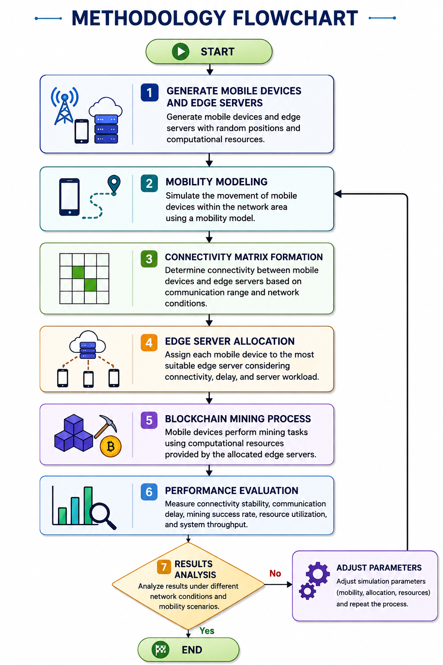
Figure 1 System Flowchart
After successful allocation, blockchain mining operations are performed using the resources provided by the assigned edge servers. The performance of the proposed framework is evaluated using several metrics, including winner miners, social welfare, resource utilization, connectivity ratio, average connected servers, final score, and allocation success rate. These metrics are used to measure the effectiveness of the allocation mechanism under dynamic mobility conditions.
Finally, the simulation results are analyzed to evaluate the overall performance of the proposed approach. If the desired performance objectives are not achieved, simulation parameters such as mobility characteristics, communication range, and resource capacities can be adjusted and the process repeated. This iterative approach enables comprehensive evaluation of the proposed Moving Mobile Device to Edge Server Resource Allocation framework under different network scenarios.

System Model
The proposed system consists of three major components:
- Mobile Devices (Miners)
Mobile devices perform blockchain mining tasks. Each device has mobility and changes its position over time.
- Edge Servers
Edge servers provide computational support to nearby mobile devices and manage miner allocation.
- Blockchain Network
The blockchain network records mining results and validates generated blocks.

The communication process between mobile devices and edge servers occurs in discrete time intervals.

Mobility Model
The movement of mobile devices is simulated using a dynamic mobility model to represent realistic changes in device locations over time. Initially, at time (t=0), all mobile devices transmit their position coordinates to the edge server. As the simulation progresses, the position of each mobile device is updated at every subsequent time interval. The updated location of mobile device (i) at time (t+1) is calculated using Equation (1):

$$P_{i}(t+1)=P_{i}(t)+ΔP_{i}$$ | ---------------------------------(1)

Where:
- $P_{i}(t)$= current position of device $i$
- $ΔP_{i}$= movement displacement of the device
- $P_{i}(t+1)$= updated position after movement
Only the miner locations change at each time step, while edge server locations remain fixed.

Communication Process
The communication process follows two stages:

Stage 1: Position Request
At time $t=0$, the mobile device sends its location information to the edge server.

Stage 2: Delayed Miner Data Transmission
After a delay of one second, the mobile device sends updated miner information to the edge server. This delay represents practical network latency and communication overhead in real-world systems. The communication delay between the mobile device and the edge server can be defined by Equation (2):
$T_{total}=T_{request}+1 second$ | ---------------------------------(2)
Where:
- $T_{request}$= initial request transmission time
- $T_{total}$= total communication delay

Connectivity Matrix Design
A connectivity matrix is used to determine whether a mobile device can connect to an edge server. The matrix is updated dynamically after each location update. The connectivity status between a mobile device and an edge server is determined based on their communication range, as defined in Equation (3). If the distance between the mobile device and edge server is less than or equal to the communication range of the edge server, the connectivity value is assigned as 1; otherwise, it is assigned as 0.
$$C_{ij}(t)=\left\{\begin{matrix}1, & d_{ij}(t)≤R_{j} \\ 0, & d_{ij}(t)>R_{j}\end{matrix}\right.$$ | ---------------------------------(3)
Where:
- $C_{ij}(t)$= connectivity status between device $i$and edge server $j$
- $d_{ij}(t)$= distance between mobile device and edge server
- $R_{j}$= communication range of edge server $j$
If the distance between the mobile device and edge server is less than the communication range, the connectivity value becomes 1; otherwise, it becomes 0.
The distance calculation is given by Equation 4:
$$d_{ij}=\sqrt{{\left(x_{i}-x_{j})^{2}+(y_{i}-y_{j}\right)}^{2}}$$ | ---------------------------------(4)
Where:
- $\left(x_{i} , y_{i}\right)$= coordinates of mobile device
- $\left(x_{j} , y_{j}\right)$= coordinates of edge server

Edge Server Allocation
After generating the connectivity matrix, mobile devices are allocated to suitable edge servers. The allocation process selects the nearest available edge server that satisfies the connectivity requirement. The edge server assignment is performed by choosing the server with the minimum distance from the mobile device, as defined in Equation (5). This allocation is subject to the condition that a valid communication link exists between the mobile device and the selected edge server $\left(C_{ij} = 1\right)$. By allocating devices to the nearest connected edge server, the proposed system reduces communication delay and improves mining efficiency.
$$A_{i}=arg⁡{min⁡}_{j}(d_{ij})$$ | ---------------------------------(5)
Subject to:
$$C_{ij}=1$$
Where:
- $A_{i}$= allocated edge server for device $i$
- $d_{ij}$= distance between device and edge server
This approach reduces communication delay and improves mining efficiency.

Blockchain Mining Process
After successful allocation, mobile devices perform blockchain mining operations using the computational resources provided by the allocated edge servers. The edge servers assist the miners by providing computational power and storage resources required for mining tasks.
The mining process begins after a miner establishes stable connectivity with an edge server and receives the required resources. The mining performance of the proposed framework depends on several important factors including:
- connectivity stability
- communication delay
- mobile device mobility
- edge server workload
- resource availability
Stable connectivity between mobile devices and edge servers improves mining continuity and reduces mining interruption caused by frequent disconnections. Similarly, lower communication delay improves synchronization between miners and edge servers during block generation and verification.
The mobility of mobile devices continuously changes the network topology, which directly affects miner connectivity and mining performance. Therefore, the proposed framework dynamically updates connectivity conditions and reallocates miners when necessary.
After successful mining, the generated blocks are transmitted to the blockchain network for validation and verification. The blockchain network verifies:
- mining correctness
- transaction integrity
- block consistency
before appending the generated blocks into the blockchain ledger.
The proposed blockchain mining framework improves mining efficiency by integrating:
- mobility-aware connectivity analysis
- delay-aware communication
- adaptive edge server allocation
- connectivity-aware miner selection
within dynamic IoV environments.

Simulation Parameters
The proposed simulation environment consists of multiple parameters used to model dynamic vehicular communication and blockchain-enabled edge resource allocation.
The major simulation parameters include:
- number of mobile devices
- number of edge servers
- communication range
- mobile device mobility speed
- simulation time interval
- communication delay
- mining workload
- allocation efficiency
- edge server resource capacity
The simulation dynamically updates the positions of mobile devices during every simulation interval according to the mobility model. After each mobility update, the connectivity matrix between mobile devices and edge servers is recalculated to reflect the continuously changing network topology.
The communication range parameter determines whether a mobile device can establish connectivity with a nearby edge server. Similarly, the communication delay parameter models realistic network latency during miner-server communication.
The simulation also considers heterogeneous edge server resources, where each edge server contains different CPU and storage capacities. The resource allocation mechanism dynamically assigns miners to suitable edge servers according to:
- connectivity conditions
- resource availability
- communication stability
- miner priority
The proposed simulation environment enables realistic analysis of:
- miner mobility
- dynamic connectivity
- blockchain mining performance
- edge resource allocation
- communication stability
under highly dynamic IoV conditions.

Performance Metrics
The effectiveness of the proposed blockchain-enabled mobile device to edge server allocation framework is evaluated using several performance metrics. These metrics are used to analyze connectivity stability, mining efficiency, communication performance, and resource utilization within dynamic IoV environments.

Allocation Efficiency
Allocation efficiency measures the percentage of mobile devices successfully allocated to edge servers for blockchain mining operations.
Higher allocation efficiency indicates:
- improved connectivity stability
- efficient resource management
- reduced allocation failure

3.9.2 Connectivity Ratio
The connectivity ratio evaluates the proportion of mobile devices that are successfully connected to edge servers during each simulation interval. It serves as an important performance metric for measuring network connectivity and communication reliability. The connectivity ratio is calculated as the ratio of connected mobile devices to the total number of mobile devices in the network, as defined in Equation (6). A higher connectivity ratio indicates more reliable miner-server communication, improved connectivity stability, and enhanced overall network performance.
$$Connectivity Ratio=\frac{ConnectedMiners}{TotalMiners}$$ | ---------------------------------(6)
Higher connectivity ratio indicates:
- reliable miner-server communication
- improved connectivity stability
- enhanced network performance

3.9.3 Communication Delay
Communication delay measures the total latency between mobile devices and edge servers during data transmission and resource allocation.
Lower communication delay improves:
- synchronization between miners and servers
- mining response time
- allocation speed
- communication efficiency

3.9.4 Mining Success Rate
Mining success rate measures the percentage of mobile devices successfully completing blockchain mining tasks.
Higher mining success rate indicates:
- stable connectivity
- efficient resource allocation
- reliable mining operations

3.9.5 Edge Server Utilization
Edge server utilization evaluates the efficiency of computational and storage resource usage within edge servers. It is an important performance metric for assessing how effectively the available edge server resources are utilized during the allocation process. The utilization ratio is calculated as the proportion of resources currently in use to the total resources available at the edge server, as defined in Equation (7). A higher utilization value indicates balanced workload distribution, efficient resource consumption, and reduced resource wastage across the network.
$$Utilization=\frac{UsedResources}{TotalResources}$$ | ---------------------------------(7)

Higher utilization indicates:
- balanced workload distribution
- efficient resource consumption
- reduced resource wastage

3.9.6 Network Stability
Network stability evaluates the reliability and consistency of miner connectivity under continuously changing vehicular mobility conditions. In vehicular blockchain networks, vehicles acting as miners frequently change their locations, speeds, and communication links, making stable network connectivity a critical performance factor. A highly stable network ensures that miners remain connected to servers and neighboring nodes with minimal disruptions, enabling efficient blockchain operations.
Higher network stability provides several advantages. First, it reduces communication interruptions caused by frequent handovers, signal fluctuations, and network topology changes. Second, it maintains stable miner–server connectivity, allowing miners to exchange transactions, blocks, and validation messages without significant delays. Third, it improves mining continuity by preventing unexpected disconnections that could interrupt the mining process or lead to wasted computational resources.
Additionally, increased network stability enhances transaction propagation efficiency, ensuring that newly generated transactions and blocks are disseminated quickly across the network. It also reduces packet loss and retransmission overhead, leading to better bandwidth utilization and lower communication costs. Stable connectivity further improves consensus reliability by enabling timely participation of miners in validation and block verification processes. As a result, the blockchain network experiences lower latency, higher throughput, improved synchronization among nodes, and greater overall robustness. Therefore, network stability is a key indicator of the effectiveness and dependability of blockchain-enabled vehicular networks.

3.9.7 Throughput
Throughput represents the total number of successful blockchain mining operations completed within a given simulation period. It is a key performance metric used to assess the efficiency and productivity of blockchain-enabled mining systems in dynamic Internet of Vehicles (IoV) environments. Since vehicular networks are characterized by high mobility, varying network conditions, and limited computational resources, achieving high throughput is essential for maintaining efficient blockchain operations.
Higher throughput indicates efficient mining performance, as a greater number of mining tasks are successfully executed and validated within the available time. It also reflects improved communication stability, ensuring that miners can reliably exchange transactions, blocks, and consensus-related messages with edge servers and neighboring nodes. Furthermore, increased throughput demonstrates effective edge resource allocation, where computational and communication resources are optimally distributed among participating vehicles and edge servers to maximize mining efficiency.
In addition, high throughput contributes to faster transaction processing, reduced waiting times, and better utilization of available network resources. It enhances the scalability of the blockchain system by enabling the network to handle a larger volume of mining activities without significant performance degradation. Higher throughput also supports timely block generation, improved consensus efficiency, and greater overall system responsiveness. Together with metrics such as latency, energy consumption, and network stability, throughput provides a comprehensive evaluation of the effectiveness of the proposed mobile device-to-edge server allocation framework for blockchain-enabled mining in dynamic IoV environments.

CHAPTER 4: EXPERIMENT SETTINGS

Experimental Environment
The proposed blockchain-enabled IoV resource allocation framework was implemented using Python programming language. The simulation environment models a dynamic mobile vehicular network integrated with heterogeneous edge servers. The experiment incorporates delay-aware connectivity, mobility-aware communication, adaptive connectivity range, and multi-server connectivity analysis for intelligent resource allocation.
The simulation considers mobile miners (vehicles) moving continuously in a two-dimensional geographical area while edge servers remain fixed at predefined locations. The proposed framework dynamically updates the connectivity matrix according to miner mobility and communication delay. Resource allocation decisions are then performed based on connectivity stability, server availability, and miner priority.

Simulation Area
A square simulation area of: 5000 * 5000 square units. Both mobile miners and edge servers were randomly deployed inside the simulation area to model realistic vehicular communication environments. The large deployment area enables dynamic topology variation and continuously changing connectivity conditions.

Miner Configuration
A total of 1000 mobile miners were dynamically generated during the simulation. Each miner represents a mobile vehicle participating in the blockchain-enabled Internet of Vehicles (IoV) resource allocation framework. The miners were assigned mobility, computational, and economic attributes to facilitate mobility analysis, connectivity prediction, and resource allocation. The configuration parameters and their corresponding ranges are summarized in Table 1.
Parameter | Description | Data Range
Miner ID | Unique miner identifier | 1 – 100
Position (X,Y) | Current geographical location | X: 0–1000 m, Y: 0–1000 m
Speed | Vehicle mobility speed | 10–100 km/h
Direction | Vehicle movement angle | 0°–360°
Bid Value | Economic contribution of miner | 10–100 monetary units
CPU Demand | Required computational resources | 1–10 CPU units
Storage Demand | Required storage resources | 10–100 GB
Execution Time | Task execution duration | 1–20 s
Table 1 Miner Configuration Parameters

Vehicle Mobility Settings
The mobility model updates the position of each miner dynamically after every simulation interval. The new coordinates are computed based on the miner's current position, movement speed, and direction of travel. The horizontal position is updated using Equation (8), while the vertical position is updated using Equation (9). Together, these equations determine the miner's new location at time $\left(t + 1\right)$, enabling continuous movement throughout the simulation and reflecting realistic changes in spatial distribution within the mining environment. This dynamic mobility model allows the proposed system to evaluate resource allocation and connectivity performance under varying movement conditions.
$$x(t+1)=x(t)+vcos⁡(θ)$$ | ---------------------------------(8)
$$y(t+1)=y(t)+vsin⁡(θ)$$ | ---------------------------------(9)
where (x(t)) and (y(t)) represent the current coordinates of the miner, (v) denotes the vehicle speed, and $θ$ represents the movement direction. The mobility parameters used in the simulation are summarized in Table 2.
Symbol | Meaning
V | Vehicle speed
Θ | Movement direction
Table 2 Vehicle Mobility Settings
The speed of miners was randomly generated within the range:
$$100≤v≤300$$
to represent highly dynamic vehicular mobility conditions.
The movement direction of miners was randomly initialized between:
$$0≤θ≤2π$$
radians.

Edge Server Configuration
The simulation environment includes 10 heterogeneous edge servers deployed at fixed locations throughout the network. Each edge server is characterized by multiple resource parameters, including geographical position, communication range, processing capacity, and storage capacity. These parameters are used to support resource allocation, task offloading, and service provisioning within the blockchain-enabled Internet of Vehicles (IoV) framework. The edge server configuration parameters used in the simulation are summarized in Table 3.
Parameter | Description | Data Range
Server ID | Unique server identifier | 1–20
Position (X,Y) | Fixed server location | X: 0–1000 m, Y: 0–1000 m
Communication Range | Wireless coverage area | 100–500 m
CPU Capacity | Available processing resources | 50–500 CPU units
Storage Capacity | Available storage resources | 500–5000 GB
Table 3 Edge Server Parameters
The communication range of edge servers was randomly initialized within $500≤R≤1000$ units. The generated edge server dataset was also exported into Excel format.

Communication Delay Settings
The proposed framework incorporates a delay-aware communication mechanism to model realistic vehicular communication behavior. At time $t$miners transmit their location information and resource requests to nearby edge servers. However, the edge servers process the received information after a communication delay interval of $1 sec$ During this delay period, miners continue moving dynamically. Consequently, the connectivity information available at the edge server becomes outdated, creating stale topology conditions.
This delay-aware mechanism enables realistic modeling of communication latency in IoV environments.

Simulation Time Settings
The total simulation duration was configured as $60 sec$. The connectivity matrix and miner mobility were updated after every $1sec$ simulation interval.
Thus, the total number of simulation rounds is calculated as:
$$Rounds=\frac{60}{1}=60$$
Each simulation round dynamically updates:
- miner positions
- connectivity matrix
- adaptive communication range
- resource allocation decisions

Distance-Evolution-Aware Connectivity
The proposed framework dynamically analyzes miner–server connectivity by monitoring the evolution of the Euclidean distance between mobile miners and edge servers over consecutive simulation intervals. The current distance between miner (i) and edge server (j) is calculated using (10), while the updated distance after miner mobility is determined using (11). The variation in distance is then obtained through (12), enabling the framework to quantify mobility-induced changes in connectivity conditions. A negative distance variation (($ΔD$ < 0)) indicates that the miner is approaching the edge server, whereas a positive distance variation (($ΔD$ > 0)) signifies that the miner is moving away from it. The interpretation of distance variation is summarized in Table 4. By continuously evaluating distance evolution, the proposed model supports predictive connectivity analysis and facilitates intelligent resource allocation decisions within the blockchain-enabled IoV environment.
$$D_{ij}(t)=\sqrt{{\left(x_{i}-x_{j})^{2}+(y_{i}-y_{j}\right)}^{2}}$$ | ---------------------------------(9)

$$D_{ij}(t)=\sqrt{{\left(x_{i}-x_{j})^{2}+(y_{i}-y_{j}\right)}^{2}}$$ | ---------------------------------(10)
Similarly, the updated distance after miner mobility is computed as:
$$D_{ij}(t+1)=\sqrt{{\left(x_{i}^{'}-x_{j})^{2}+(y_{i}^{'}-y_{j}\right)}^{2}}$$ | ---------------------------------(11)
The distance variation is then calculated using:
$$ΔD=D_{ij}(t+1)-D_{ij}(t)$$ | ---------------------------------(12)

where:
Condition | Interpretation
$ΔD$ < 0 | Miner approaching server
$ΔD$ > 0 | Miner moving away from server
Table 4 Distance-Evolution Interpretation
This mechanism enables predictive connectivity analysis based on vehicle movement behavior.

Adaptive Connectivity Range
The proposed framework employs an adaptive connectivity mechanism that dynamically adjusts the effective communication range according to miner movement behavior. Rather than relying on a fixed communication range, the effective range is calculated using (13), which incorporates the change in distance between the miner and the edge server. This approach enables the communication range to adapt to mobility-induced variations in network topology. When a miner moves closer to the edge server, the effective communication range increases, improving the likelihood of maintaining a stable connection. Conversely, when a miner moves away from the server, the effective communication range decreases, reflecting reduced connectivity potential. The parameters used in the adaptive connectivity model are summarized in Table 5. By continuously adapting the communication range based on miner mobility, the proposed mechanism enhances connectivity prediction accuracy and improves communication stability in highly dynamic blockchain-enabled IoV environments.
$$R_{effective}=R-ΔD$$ | ---------------------------------(13)
where:
Symbol | Meaning
R | Original server communication range
$$ΔD$$ | Distance variation
Table 5 Adaptive Connectivity Range
If a miner approaches the server, the effective range increases. Conversely, when a miner moves away from the server, the effective range decreases.
This adaptive mechanism improves connectivity prediction and communication stability in highly mobile IoV environments.

Connectivity Matrix Generation
The connectivity matrix between miners and edge servers is dynamically generated during each simulation interval to reflect real-time network conditions. Connectivity between miner (i) and edge server (j) is established based on the condition specified in Equation (14), which compares the updated miner–server distance with the adaptive communication range. If the updated distance remains within the effective communication range, the connectivity state is assigned a value of 1, indicating an active connection. Otherwise, the connectivity state is assigned a value of 0, representing a disconnected condition. As miners move throughout the network, the connectivity matrix is continuously updated, capturing changes in communication links caused by mobility, communication delay, and variations in the adaptive connectivity range.
$$C_{ij}=1ifD_{ij}(t+1)≤R_{effective}$$ | ---------------------------------(14)

Otherwise:
$$C_{ij}=0$$
where:
- 1 represents connected state
- 0 represents disconnected state
The connectivity matrix dynamically changes according to miner mobility, communication delay, and adaptive connectivity range.

Multi-Server Connectivity Analysis
The proposed framework evaluates the connectivity robustness of each miner by calculating the total number of edge servers connected to it using Equation (15). This metric represents the number of active communication links available to a miner during a simulation interval. Miners with connections to multiple edge servers are considered more stable and reliable for resource allocation, as they can utilize alternative communication paths when connectivity with a particular server degrades or becomes unavailable. By incorporating the number of connected servers into the decision-making process, the framework enhances connectivity stability, increases the probability of successful resource allocation, and improves the overall reliability of resource distribution in dynamic IoV environments.
$$ConnectedServers_{i}=\sum_{j}{C_{ij}}$$ | ---------------------------------(15)

Miner Priority Calculation
The proposed framework determines the economic and computational priority of each miner using Equation (16), which integrates bidding value and resource requirements into a single priority metric. This priority score reflects the relative efficiency of a miner by considering the bid offered in relation to the required CPU resources, storage capacity, and execution time. Miners with higher bid values and lower resource demands achieve higher priority scores, making them more favorable candidates for resource allocation. By balancing economic incentives with computational efficiency, the priority calculation supports fair and effective resource distribution while improving overall system utilization and allocation performance.
$$Priority=\frac{Bid}{CPU×Storage×ExecutionTime}$$ | ---------------------------------(16)

This equation prioritizes miners that:
- provide higher economic contribution
- consume fewer resources
- complete tasks quickly

Final Miner Selection Score
The proposed framework integrates connectivity stability and miner priority into a unified decision metric using Equation (17). The final score is calculated by combining the number of connected edge servers with the miner's priority value, thereby capturing both network reliability and resource efficiency. Miners that maintain connections with multiple edge servers and exhibit higher priority scores achieve larger final scores, making them more suitable candidates for resource allocation. Resources are allocated preferentially to miners with the highest final scores, ensuring that allocation decisions consider connectivity robustness, economic contribution, computational efficiency, and task execution requirements simultaneously. This scoring mechanism enhances allocation effectiveness while improving overall system reliability and performance in dynamic IoV environments.
$$FinalScore=ConnectedServerCount×Priority$$ | ---------------------------------(17)
Miners with higher final scores are allocated resources first.
The final score simultaneously considers:
- multi-server connectivity
- economic contribution
- resource efficiency
- task execution time

Performance Evaluation Metrics
The performance of the proposed framework was evaluated using multiple metrics that measure allocation efficiency, economic effectiveness, resource utilization, and network stability. The selected performance metrics include the total number of successful miner allocations, allocation failures, overall social welfare, edge resource utilization efficiency, and network connectivity stability. These metrics provide a comprehensive assessment of the proposed blockchain-enabled Internet of Vehicles (IoV) resource allocation framework. The performance evaluation metrics used in the simulation are summarized in Table 6.
Metric | Description
Winner Miners | Total successful allocations
Runner-Up Miners | Allocation failures
Social Welfare | Total economic benefit
Resource Utilization | Edge resource efficiency
Connectivity Ratio | Network connectivity stability
Table 6 Performance Evaluation Metrics

Social Welfare
The proposed framework evaluates the overall economic performance of the system by calculating the total social welfare using Equation (18). This metric is obtained by summing the bid values of all participating miners, where each bid represents the economic contribution of a miner to the resource allocation process. A higher social welfare value indicates that the framework is effectively allocating resources to miners with greater economic significance, thereby maximizing the overall benefit derived from available computational resources. Consequently, social welfare serves as an important indicator of the economic efficiency and effectiveness of the proposed resource allocation framework.
$$SocialWelfare=∑Bid_{i}$$ | ---------------------------------(18)
where:
- $Bid_{i}$represents the economic contribution of miner $i$
Social welfare measures the overall economic efficiency of the proposed framework.

4.16 Resource Utilization
The proposed framework assesses the efficiency of edge server resource management by calculating resource utilization using Equation (19). This metric represents the proportion of available computational and storage resources that are actively allocated and utilized within the edge computing environment. By comparing the amount of used resources to the total available resources, the framework can evaluate how effectively the infrastructure supports miner requests and task execution. Higher resource utilization values indicate more efficient server usage, reduced resource wastage, and a balanced distribution of resources across the network. Consequently, this metric serves as a key performance indicator for measuring the effectiveness of the resource allocation strategy and the overall operational efficiency of the edge computing system.
$$Utilization=\frac{UsedResources}{TotalResources}$$ | ---------------------------------(19)

This metric evaluates the efficiency of computational and storage resource usage within the edge computing environment.
Higher resource utilization indicates:
- efficient server usage
- reduced resource wastage
- balanced resource allocation

Connectivity Ratio
The proposed framework evaluates network connectivity stability by calculating the connectivity ratio using Equation (20). This metric represents the proportion of miners that maintain successful connections with edge servers during a simulation interval and is obtained by comparing the number of connected miners to the total number of miners in the network. A higher connectivity ratio indicates that a larger percentage of miners can reliably communicate with edge servers, reflecting improved network stability and communication availability. Consequently, this metric serves as an important indicator of the effectiveness of the connectivity prediction mechanism, with higher values demonstrating more stable communication links, enhanced connectivity prediction accuracy, and more reliable communication conditions in dynamic IoV environments.
$ConnectivityRatio=\frac{ConnectedMiners}{TotalMiners}$ | ---------------------------------(20)

This metric measures the proportion of miners successfully connected to edge servers during each simulation interval.
Higher connectivity ratio indicates:
- stable communication
- improved connectivity prediction
- reliable IoV communication conditions

Experimental Comparison Factors
The proposed framework was evaluated under various experimental settings to investigate the impact of mobility, communication constraints, network coverage, scalability, and miner density on overall system performance. The analysis considered different values of vehicle speed and miner density, while maintaining fixed communication delay, communication range, and edge server deployment parameters. These experimental factors enable a comprehensive assessment of the framework's behavior under diverse network conditions and resource allocation scenarios. The experimental comparison factors used in the simulation are summarized in Table 7.
Factor | Values
Vehicle Speed | 50, 100, 200, 300
Communication Delay | 1 sec
Communication Range | 300
Number of Edge Servers | 10
Miner Density | 200, 500, 1000
Table 7 Experimental Comparison Factors
These factors were used to analyze the impact of mobility, delay, connectivity coverage, scalability, and network density on resource allocation performance.

4.19 Resource Allocation Strategy
The proposed resource allocation strategy is designed to efficiently assign blockchain mining tasks to edge servers in dynamic Internet of Vehicles (IoV) environments. Since vehicular nodes experience frequent mobility and varying network conditions, the allocation process considers multiple factors to ensure reliable and effective utilization of edge resources.
Resource allocation is performed based on the following conditions:
- Connectivity Availability: The miner must maintain an active and reliable connection with an edge server to support continuous communication and mining operations.
- Multi-Server Connectivity: Preference is given to miners that can establish connectivity with multiple edge servers, improving allocation flexibility and reducing the risk of service disruption.
- Available CPU Resources: The edge server must possess sufficient computational capacity to execute mining-related tasks efficiently.
- Available Storage Resources: Adequate storage space must be available for transaction processing, blockchain data management, and temporary mining operations.
- Final Miner Selection Score: A composite score is calculated based on connectivity quality, resource availability, and other performance factors to identify the most suitable miner-server pairing.
A miner is designated as a winner miner when an edge server successfully allocates the required computational and storage resources for mining. Conversely, if sufficient resources cannot be allocated, the miner is classified as a runner-up miner. The framework dynamically matches miners with the most appropriate edge servers based on connectivity stability and resource availability, thereby improving mining efficiency, reducing allocation failures, enhancing resource utilization, and supporting uninterrupted blockchain operations in highly mobile IoV environments.

CHAPTER 5: RESULTS AND DISCUSSION

5.1 Overview
The proposed multi-server connectivity-aware resource allocation model was evaluated in a blockchain-enabled mobile edge computing environment. The experimental results demonstrate the effectiveness of the proposed allocation strategy in improving winner miner selection, maximizing social welfare, enhancing resource utilization, and maintaining stable connectivity performance. The simulation dynamically allocates edge server resources to blockchain miners based on connectivity conditions, bid values, computational demand, storage demand, and execution time.

Winner Miner Analysis
The Winner Miners graph illustrates the number of miners that successfully obtained resources from edge servers over the simulation period.
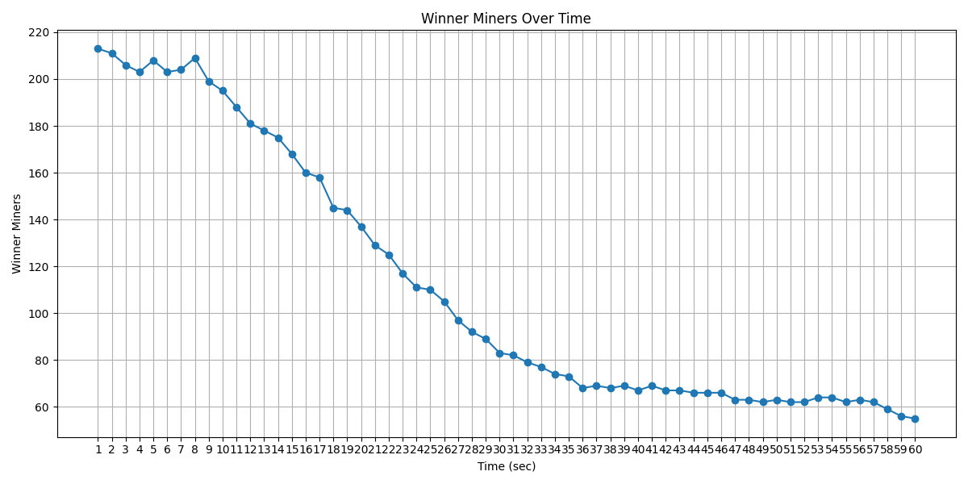
Figure 2 Winner Miners vs Time
Initially, the system allocated resources to approximately 213 miners during the first second of the simulation. Between 1 and 10 seconds, the number of winner miners remained relatively stable, fluctuating between 200 and 210 miners. This indicates that sufficient edge resources were available during the early stages of the simulation. After the 10th second, a gradual decline in winner miners can be observed. The number decreased steadily from approximately 195 miners to around 83 miners by the 30th second. This reduction occurred because available server resources became increasingly occupied by previously allocated mining tasks. From the 35th second onwards, the winner miner count stabilized between 60 and 70 miners. At the end of the simulation, approximately 55 miners were successfully allocated resources.
The results demonstrate that the proposed allocation mechanism effectively prioritizes miners according to connectivity and resource requirements. Although the number of winners decreases over time due to resource exhaustion, the system continues to allocate resources efficiently throughout the simulation period

Social Welfare Analysis
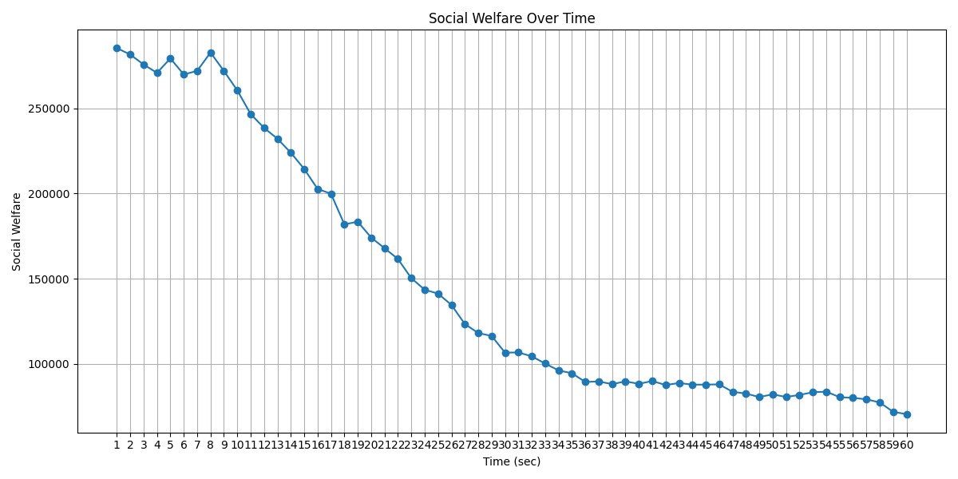
Figure 3 Social Welfare Analysis
Above figure illustrates the social welfare achieved during the simulation period. Social welfare represents the total bid value of miners that were successfully allocated computational and storage resources from edge servers. It is an important performance metric because it reflects the overall economic efficiency of the proposed resource allocation mechanism.
The graph shows that social welfare is relatively high during the initial stages of the simulation, indicating that a large number of miners with higher bid values successfully obtained resources. As the simulation progresses, social welfare gradually decreases due to the reduction in available edge server resources and increased competition among miners. Consequently, fewer miners are able to participate in the mining process, resulting in lower cumulative bid values.
Although a declining trend is observed, the decrease is gradual and stable throughout the simulation period. This behavior indicates that the proposed multi-server connectivity-aware allocation strategy continues to allocate resources efficiently even under limited resource conditions. The allocation mechanism prioritizes miners based on connectivity and resource requirements, ensuring that available resources are assigned to suitable miners.
Overall, the results demonstrate that the proposed approach effectively maximizes social welfare while maintaining stable resource allocation performance in a blockchain-enabled mobile edge computing environment.

Resource Utilization Analysis
Resource utilization represents the percentage of edge server resources actively used for blockchain mining during the simulation period. The graph shows that resource utilization is initially high, with values above 80%, indicating that most of the available resources are efficiently allocated to miners. During the first few seconds, only minor fluctuations are observed, suggesting stable resource allocation and effective utilization of edge server capacities.
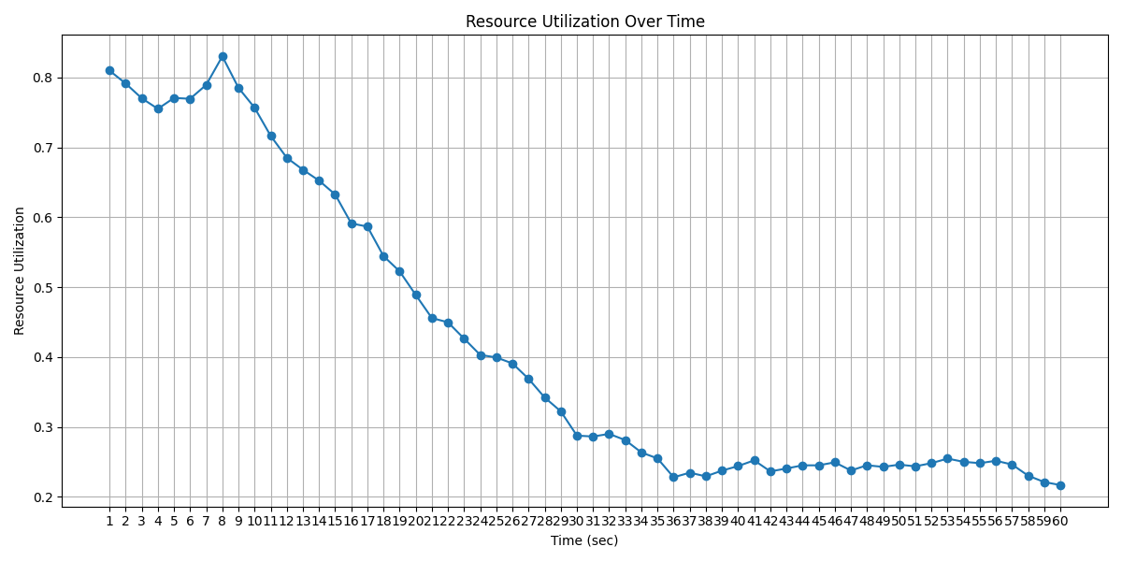
Figure 4 Resource Utilization Analysis
As the simulation progresses, resource utilization gradually decreases and reaches lower values during the later stages of the simulation. This trend occurs because the number of successfully allocated miners decreases over time, resulting in lower consumption of computational resources. After approximately the midpoint of the simulation, the graph becomes relatively stable, with utilization values fluctuating within a narrow range. This stability indicates that the proposed multi-server connectivity-aware allocation mechanism continues to distribute workloads efficiently despite changing resource availability and connectivity conditions.
Overall, the graph demonstrates that the proposed approach effectively utilizes available edge resources throughout the simulation period. The gradual decline in resource utilization reflects the dynamic allocation process rather than system inefficiency. The absence of sudden drops or irregular fluctuations further confirms the stability and reliability of the allocation strategy in supporting blockchain mining operations within a mobile edge computing environment.

Connectivity Ratio
Connectivity ratio represents the proportion of successful connections established between mobile devices and edge servers during the simulation period. It is calculated as the ratio of actual connections to the maximum possible connections between all mobile devices and available edge servers. A higher connectivity ratio indicates better communication opportunities and improved accessibility to edge computing resources.
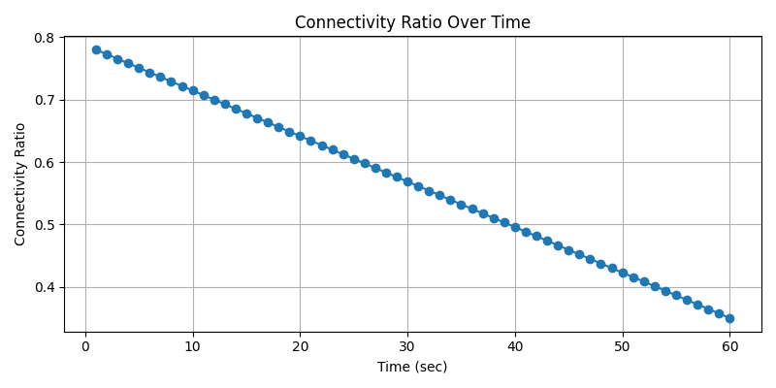
Figure 5 Connectivity Ratio
The connectivity ratio graph shows how network connectivity changes over time as mobile devices move within the simulation area. At the beginning of the simulation, the connectivity ratio is relatively high because most mobile devices are located within the communication range of one or more edge servers. As the simulation progresses, device mobility causes some devices to move away from nearby edge servers, resulting in a gradual decrease in the connectivity ratio. This behavior reflects the dynamic nature of mobile edge computing environments where connectivity continuously changes due to device movement.
Despite the decreasing trend, the connectivity ratio remains stable throughout the simulation period without significant fluctuations. This indicates that the proposed connectivity-aware allocation mechanism is capable of maintaining communication links between mobile devices and edge servers under varying mobility conditions. The results demonstrate that the connectivity matrix effectively captures network connectivity information and supports efficient resource allocation decisions.
Overall, the connectivity ratio analysis confirms that the proposed framework can adapt to dynamic network conditions while maintaining sufficient connectivity for resource allocation and blockchain mining operations. This contributes to improved allocation efficiency, better resource utilization, and enhanced system performance in the mobile edge computing environment.

CHAPTER 6: CONCLUSION AND FUTURE WORK

Conclusion
The proposed allocation framework is particularly suitable for highly dynamic mobile environments where miner mobility frequently causes changes in network topology. Traditional static allocation methods are unable to adapt efficiently to such variations, resulting in unstable connections, increased communication overhead, and reduced mining productivity. By continuously monitoring the location of mobile miners and updating connectivity information in real time, the proposed system ensures that miners remain connected to the most appropriate edge server throughout the mining process. This dynamic adaptation improves the reliability of communication and minimizes interruptions caused by mobility.
Another important advantage of the proposed model is its ability to support load balancing among multiple edge servers. As the number of mobile miners increases, some edge servers may become overloaded while others remain underutilized. The dynamic allocation mechanism distributes mining requests according to connectivity conditions and server availability, preventing congestion at individual edge servers. This balanced resource utilization helps maintain consistent service quality and enhances the overall efficiency of the edge computing infrastructure supporting blockchain operations.
Furthermore, the integration of edge computing with blockchain mining reduces the computational burden on resource-constrained mobile devices. Since mining tasks often require significant processing power and energy consumption, offloading mining-related operations to nearby edge servers enables mobile devices to participate in blockchain networks without excessive battery drain or hardware limitations. This approach not only improves mining performance but also extends the operational lifetime of mobile devices participating in the blockchain ecosystem.
The simulation results further validate the effectiveness of the proposed approach under varying mobility and network conditions. Performance metrics such as connectivity stability, average communication delay, edge server utilization, and successful miner allocation rate demonstrate noticeable improvements compared to conventional allocation methods. The dynamic connectivity matrix successfully adapts to changes in miner positions, ensuring efficient miner-to-server associations while reducing the frequency of connection failures.
In addition, the proposed framework offers scalability for future mobile blockchain applications, including Internet of Things (IoT) networks, smart transportation systems, and decentralized mobile services. As the number of connected devices continues to grow, intelligent edge server allocation mechanisms will become increasingly important for maintaining efficient blockchain operations. The presented model provides a foundation for future research on mobility-aware resource management, predictive allocation strategies, and machine learning-based optimization techniques in edge-enabled blockchain environments.
Overall, the proposed dynamic edge server allocation mechanism demonstrates significant potential for improving the performance and reliability of blockchain mining in mobile environments. By combining real-time connectivity management, efficient resource allocation, and edge computing capabilities, the system creates a robust framework capable of supporting next-generation decentralized applications in highly mobile and distributed networks.

6.2 Future Work
Although the proposed mobile device to edge server allocation model demonstrates promising results in improving connectivity stability, reducing communication delay, and enhancing blockchain mining performance, there is considerable scope for further development. As mobile blockchain networks become increasingly complex and large-scale, more intelligent and adaptive allocation mechanisms will be required to efficiently manage dynamic network conditions and continuously changing miner locations. Future research can focus on developing advanced techniques that further improve the scalability, reliability, and efficiency of the proposed framework.
One potential direction is the integration of AI and ML algorithms into the allocation process. By analyzing historical mobility patterns, network conditions, and miner behavior, predictive models can forecast future miner movements and proactively allocate resources to minimize connectivity disruptions. Such intelligent allocation strategies can reduce handover delays, improve decision-making accuracy, and optimize the utilization of edge computing resources. The incorporation of learning-based algorithms may also enable the system to adapt automatically to varying network environments and changing workloads.
Another important area for future investigation is the development of energy-efficient resource management mechanisms. Since mobile devices are constrained by battery capacity and computational capabilities, reducing energy consumption while maintaining mining performance remains a critical challenge. Advanced task offloading strategies, adaptive workload distribution techniques, and energy-aware allocation algorithms can be explored to achieve a better balance between mining efficiency and power utilization. These approaches can help extend device operating time while ensuring effective participation in blockchain mining activities.
The emergence of next-generation communication technologies such as 5G and 6G networks offers new opportunities for enhancing the proposed system. The high bandwidth, ultra-low latency, and massive connectivity provided by these technologies can significantly improve the performance of mobile blockchain and edge computing applications. Future work may involve implementing the proposed allocation framework in real-world environments using actual mobile devices, edge servers, and advanced wireless networks to evaluate its practical feasibility and performance under realistic operating conditions.
In addition, security and privacy aspects of the system can be further strengthened. Since mobile miners continuously exchange location and connectivity information with edge servers, protecting sensitive user data is essential. Future studies may investigate secure communication protocols, privacy-preserving allocation techniques, and decentralized trust management mechanisms to enhance system security without compromising performance. Technologies such as federated learning and lightweight cryptographic methods could be integrated to support secure and efficient resource allocation.
Furthermore, the proposed framework can be extended to support emerging applications such as Internet of Things (IoT) networks, smart cities, intelligent transportation systems, and other decentralized mobile services. These applications often involve large numbers of mobile devices and highly dynamic network environments, making efficient edge server allocation increasingly important. Exploring scalable multi-edge collaboration strategies and adaptive resource management techniques can help ensure reliable operation in such large-scale deployments.
Overall, future enhancements in intelligent prediction, energy optimization, security, scalability, and next-generation network integration can further improve the effectiveness of the proposed mobile device to edge server allocation model. These developments have the potential to create a more robust, efficient, and practical framework for supporting blockchain mining and decentralized applications in highly dynamic mobile environments.

REFERENCE
[1] J. Zhang, W. Lou, H. Sun, Q. Su, and W. Li, “Truthful auction mechanisms for resource allocation in the Internet of Vehicles with public blockchain networks,” Futur. Gener. Comput. Syst., vol. 132, pp. 11–24, 2022, doi: https://doi.org/10.1016/j.future.2022.02.002.
[2] Y. Jiao, P. Wang, S. Member, and D. Niyato, “Auction Mechanisms in Cloud / Fog Computing Resource Allocation for Public Blockchain Networks,” vol. 30, no. 9, pp. 1975–1989, 2019.
[3] L. Li, Y. Li, and R. Li, “Double Auction-Based Two-Level Resource Allocation Mechanism for Computation Offloading in Mobile Blockchain Application,” vol. 2021, 2021, doi: 10.1155/2021/8821583.
[4] G. Baranwal, D. Kumar, and D. Prakash, “Blockchain based resource allocation in cloud and distributed edge computing : A survey,” Comput. Commun., vol. 209, no. April, pp. 469–499, 2023, doi: 10.1016/j.comcom.2023.07.023.
[5] Z. Shi, C. De Laat, and P. Grosso, “Integration of Blockchain and Auction Models : A Survey , Some Applications , and Challenges,” IEEE Commun. Surv. Tutorials, vol. 25, no. 1, pp. 497–537, 2023, doi: 10.1109/COMST.2022.3222403.
[6] S. Li, K. Zhu, Y. Xu, R. Wang, and Y. Zhao, “Resource Allocation for Mobile Blockchain : A Hierarchical Combinatorial Auction Approach,” 2019.
[7] J. Zhang, W. Lou, H. Sun, Q. Su, and W. Li, “Truthful auction mechanisms for resource allocation in the Internet of Vehicles with public blockchain networks,” Futur. Gener. Comput. Syst., vol. 132, pp. 11–24, 2022, doi: 10.1016/j.future.2022.02.002.
[8] X. Chen, L. Jiao, W. Li, and X. Fu, “Efficient Multi-User Computation Offloading for Mobile-Edge Cloud Computing,” IEEE/ACM Transactions on Networking, vol. 24, no. 5, pp. 2795–2808, 2016, doi: 10.1109/TNET.2015.2487344.
[9] Y. Mao, C. You, J. Zhang, K. Huang, and K. B. Letaief, “A Survey on Mobile Edge Computing: The Communication Perspective,” IEEE Communications Surveys & Tutorials, vol. 19, no. 4, pp. 2322–2358, 2017, doi: 10.1109/COMST.2017.2745201.
[10] S. Wang, X. Zhang, Y. Zhang, L. Wang, J. Yang, and W. Wang, “A Survey on Mobile Edge Networks: Convergence of Computing, Caching and Communications,” IEEE Access, vol. 5, pp. 6757–6779, 2017, doi: 10.1109/ACCESS.2017.2685434.
[11] X. Xu, X. Zhang, H. Gao, Y. Xue, L. Qi, and W. Dou, “BeCome: Blockchain-Enabled Computation Offloading for IoT in Mobile Edge Computing,” IEEE Transactions on Industrial Informatics, vol. 16, no. 6, pp. 4187–4195, 2020, doi: 10.1109/TII.2019.2936869.
[12] Y. Wu, K. Zhang, and Y. Zhang, “Digital Twin Networks: A Survey,” IEEE Internet of Things Journal, vol. 8, no. 18, pp. 13789–13804, 2021, doi: 10.1109/JIOT.2021.3079517.
[13] X. Huang, R. Yu, J. Kang, N. Wang, S. Maharjan, and Y. Zhang, “Software Defined Networking Enabled Wireless Network Virtualization: Challenges and Solutions,” IEEE Network, vol. 31, no. 5, pp. 42–49, 2017, doi: 10.1109/MNET.2017.1600293.
[14] Y. Zhang, D. Niyato, P. Wang, and Z. Han, “Auction-Based Resource Allocation in Mobile Edge Computing Systems,” IEEE Wireless Communications, vol. 26, no. 4, pp. 60–66, 2019, doi: 10.1109/MWC.2019.1800446.
[15] J. Liu, Y. Mao, J. Zhang, and K. B. Letaief, “Delay-Optimal Computation Task Scheduling for Mobile-Edge Computing Systems,” IEEE International Symposium on Information Theory (ISIT), pp. 1451–1455, 2016, doi: 10.1109/ISIT.2016.7541524.
[16] M. Satyanarayanan, P. Bahl, R. Caceres, and N. Davies, “The Case for VM-Based Cloudlets in Mobile Computing,” IEEE Pervasive Computing, vol. 8, no. 4, pp. 14–23, 2009, doi: 10.1109/MPRV.2009.82.
[17] S. Wang, R. Urgaonkar, T. He, M. Zafer, K. Chan, and K. K. Leung, “Dynamic Service Placement for Mobile Micro-Clouds with Predicted Future Costs,” IEEE Transactions on Parallel and Distributed Systems, vol. 28, no. 4, pp. 1002–1016, 2017, doi: 10.1109/TPDS.2016.2603504.

